JACOBITES MOUNTAINEERING CLUB –EVENING WALKS,

Map 66. Allermuir Hill, Pentland Hills from Balerno side. An easy 8km walk on good paths starting from car park for the Ranger Centre at Harlaw.
Take the A70 until left turn to Balerno. Follow signs for Malleny, Harlaw and Ranger Centre. Car park at NT 182 655, 40mins from Edinburgh. Directly follow main path eastwards between cultivated fields for 2km until a small path diverts north-east up Harbour Hill. Continue on hill-paths over Capelaw Hill and onto Allermuir Hill. Return by the same route, or traverse around south flank of Capelaw Hill to rejoin path back up Harbour Hill.
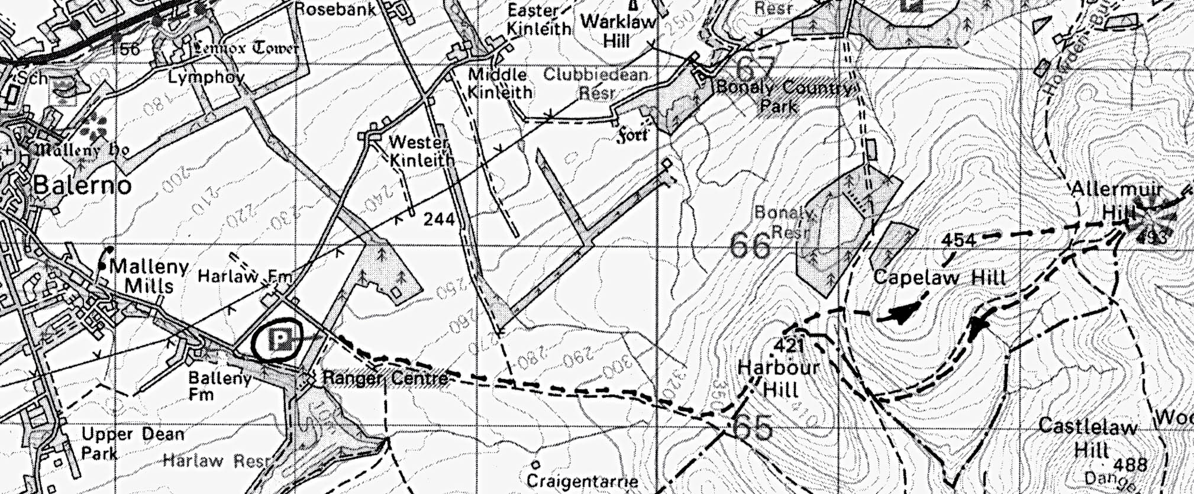

Contact:

