JACOBITES MOUNTAINEERING CLUB – EVENING WALKS

Carnethy Hill, Pentland Hills from Balerno side. A 14km circular walk starting from Ranger Centre at Harlaw. Map 66. (Fairly long; if weather is poor or energy is low, divert along the road beside Loganlea Reservoir to avoid Carnethy Hill.)
Take A70 until left turn to Balerno. Follow signs for Malleny, Harlaw and Ranger Centre. Car park is north of Ranger Centre; NT182 655, 40mins from Edinburgh. Follow main path eastwards until it turns southwards toward Black Hill. Cross the outlier of Thriepmuir Reservoir by the bridge to find the path traversing lower north west slope of Black Hill. Continue through the gorge. Just before The Howe buildings turn south east to find path that goes to the pass between Scald Law and Carnethy Hill. Up over Carnethy to the pass before Turnhouse Hill. From this pass find the quad-bike track that leads down toward Logan House. Cross Logan Burn at bridge and follow road beside Glencorse Reservoir. After the copse of trees beyond Kirkton farm, return north west on path signposted for Balerno.

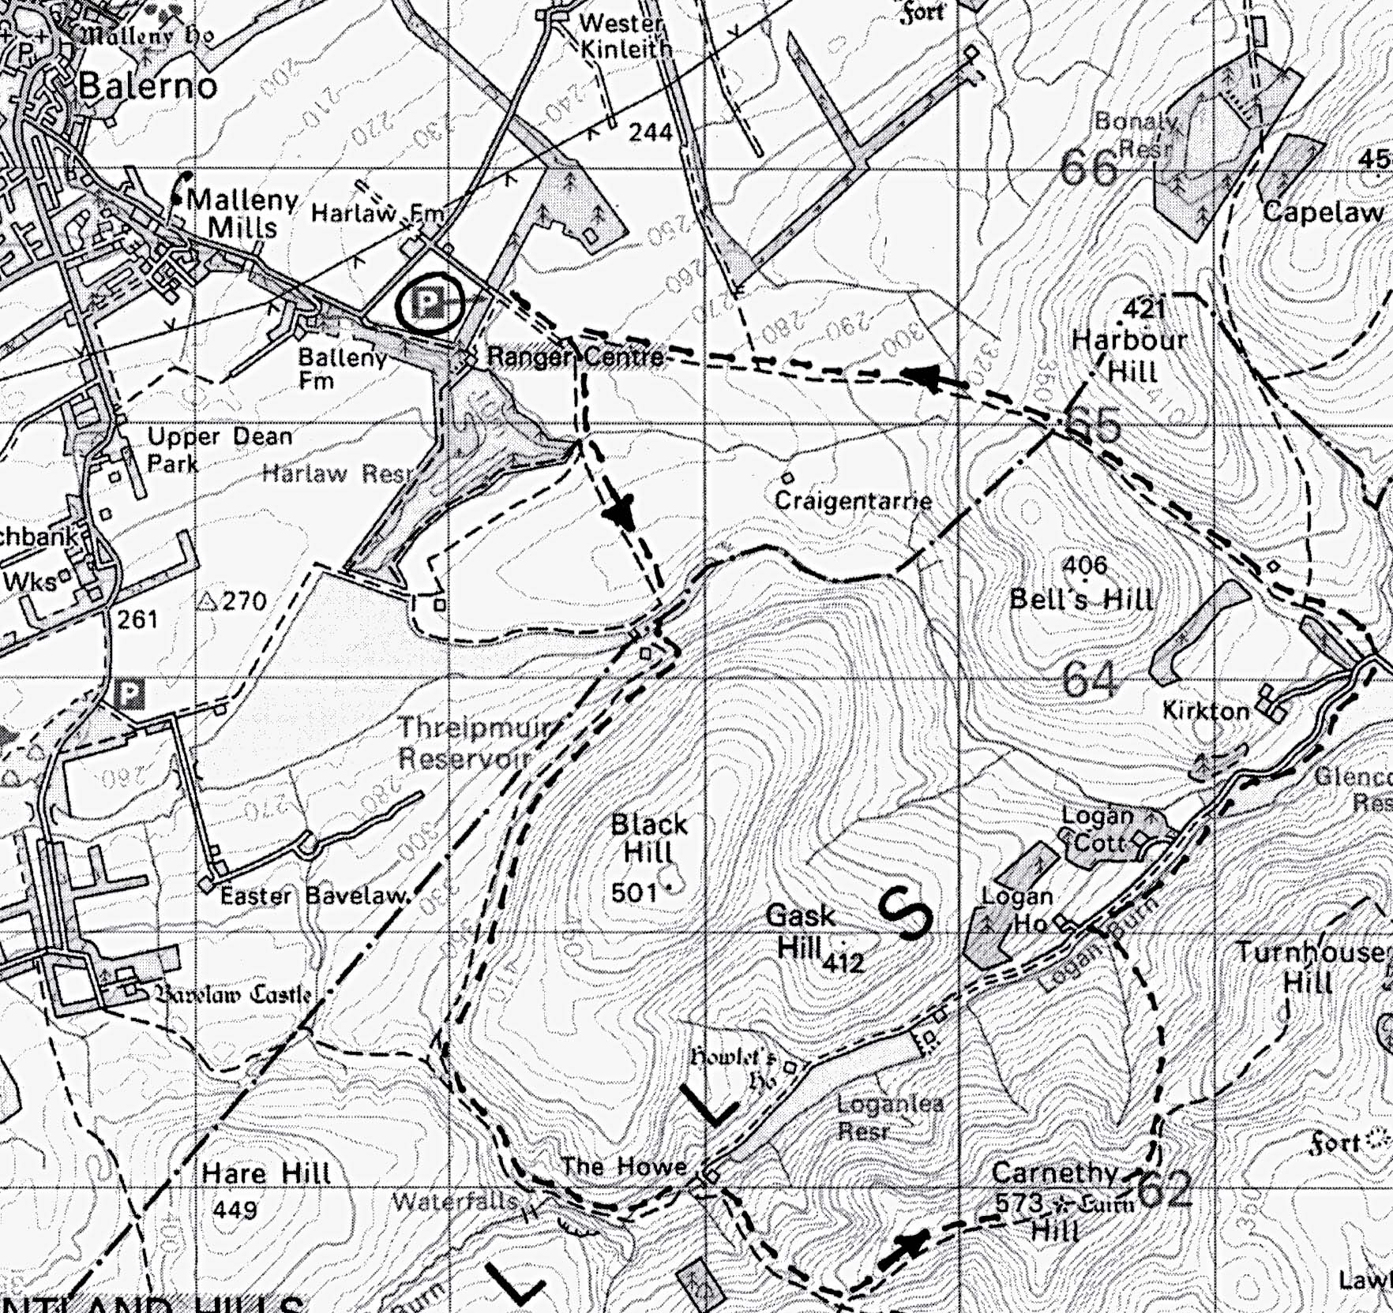

Contact:

