Jacobites Mountaineering Club – Evening Walks

Culter Fell from Holms Water Glen. 6km round trip. Steep ground with poor paths but up a fine hill from a remote glen;. Map 72, park at NS 079295, 60 mins from Edinburgh. Road signed ‘Glenholm’ turns right off A701 at 2km south of Broughton, 200m after the left turn to Drumelzier. Down glen 7km to ‘No parking beyond here’ park on grass before wall. Follow track toward Holms Waterhead until it turns left to other side of wall. From here, traverse the pasture eastwards to find a gate leading to a ramp line with quadbike track heading north west onto start of the ridge at south west of Congrie Hill. Follow track and ridge to plateau north of Culter Fell. Return via Leishfoot Hill. Don’t do other way round in poor visibility - top start of the ridge south of King Bank Head is difficult to find in the mist.

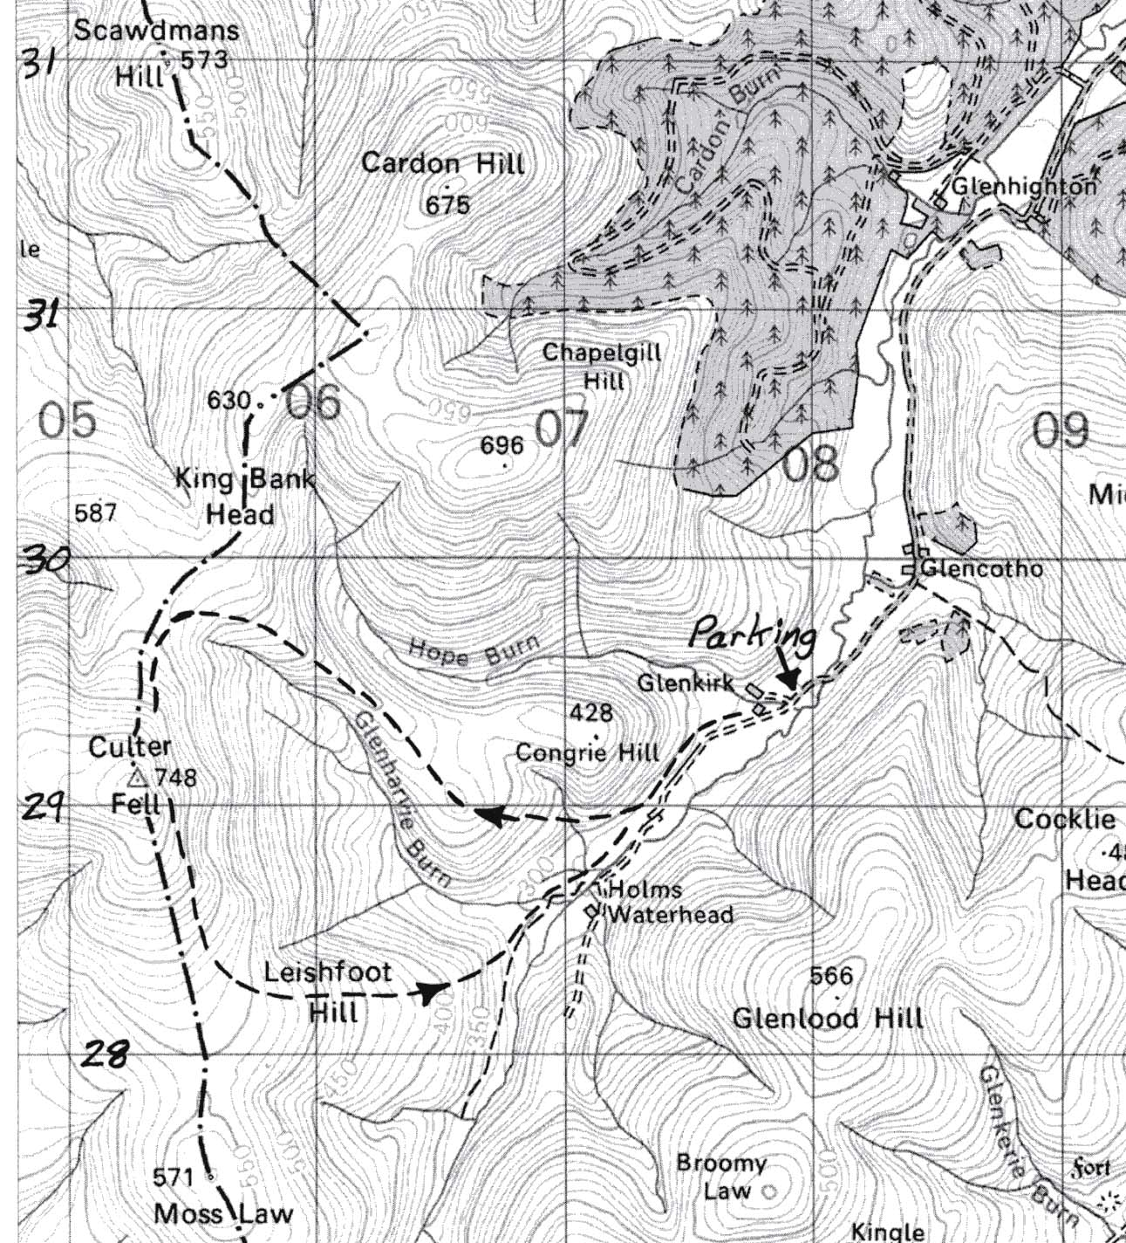

Contact:

