Jacobites Mountaineering Club – Evening Walks

Dundreich from Eddelston, Moorfoot Hills, A 7km there and back walk up steeply onto a plateau and summit with grand views of the Pentland Hills and Arthur's Seat.
Entering Eddleston from north, turn left at the signed parking for Horseshoe Inn (posh restaurant), in Burnside Street, just beyond Bellfield Road, at 243471 on map NT73. (50 mins from Edinburgh)
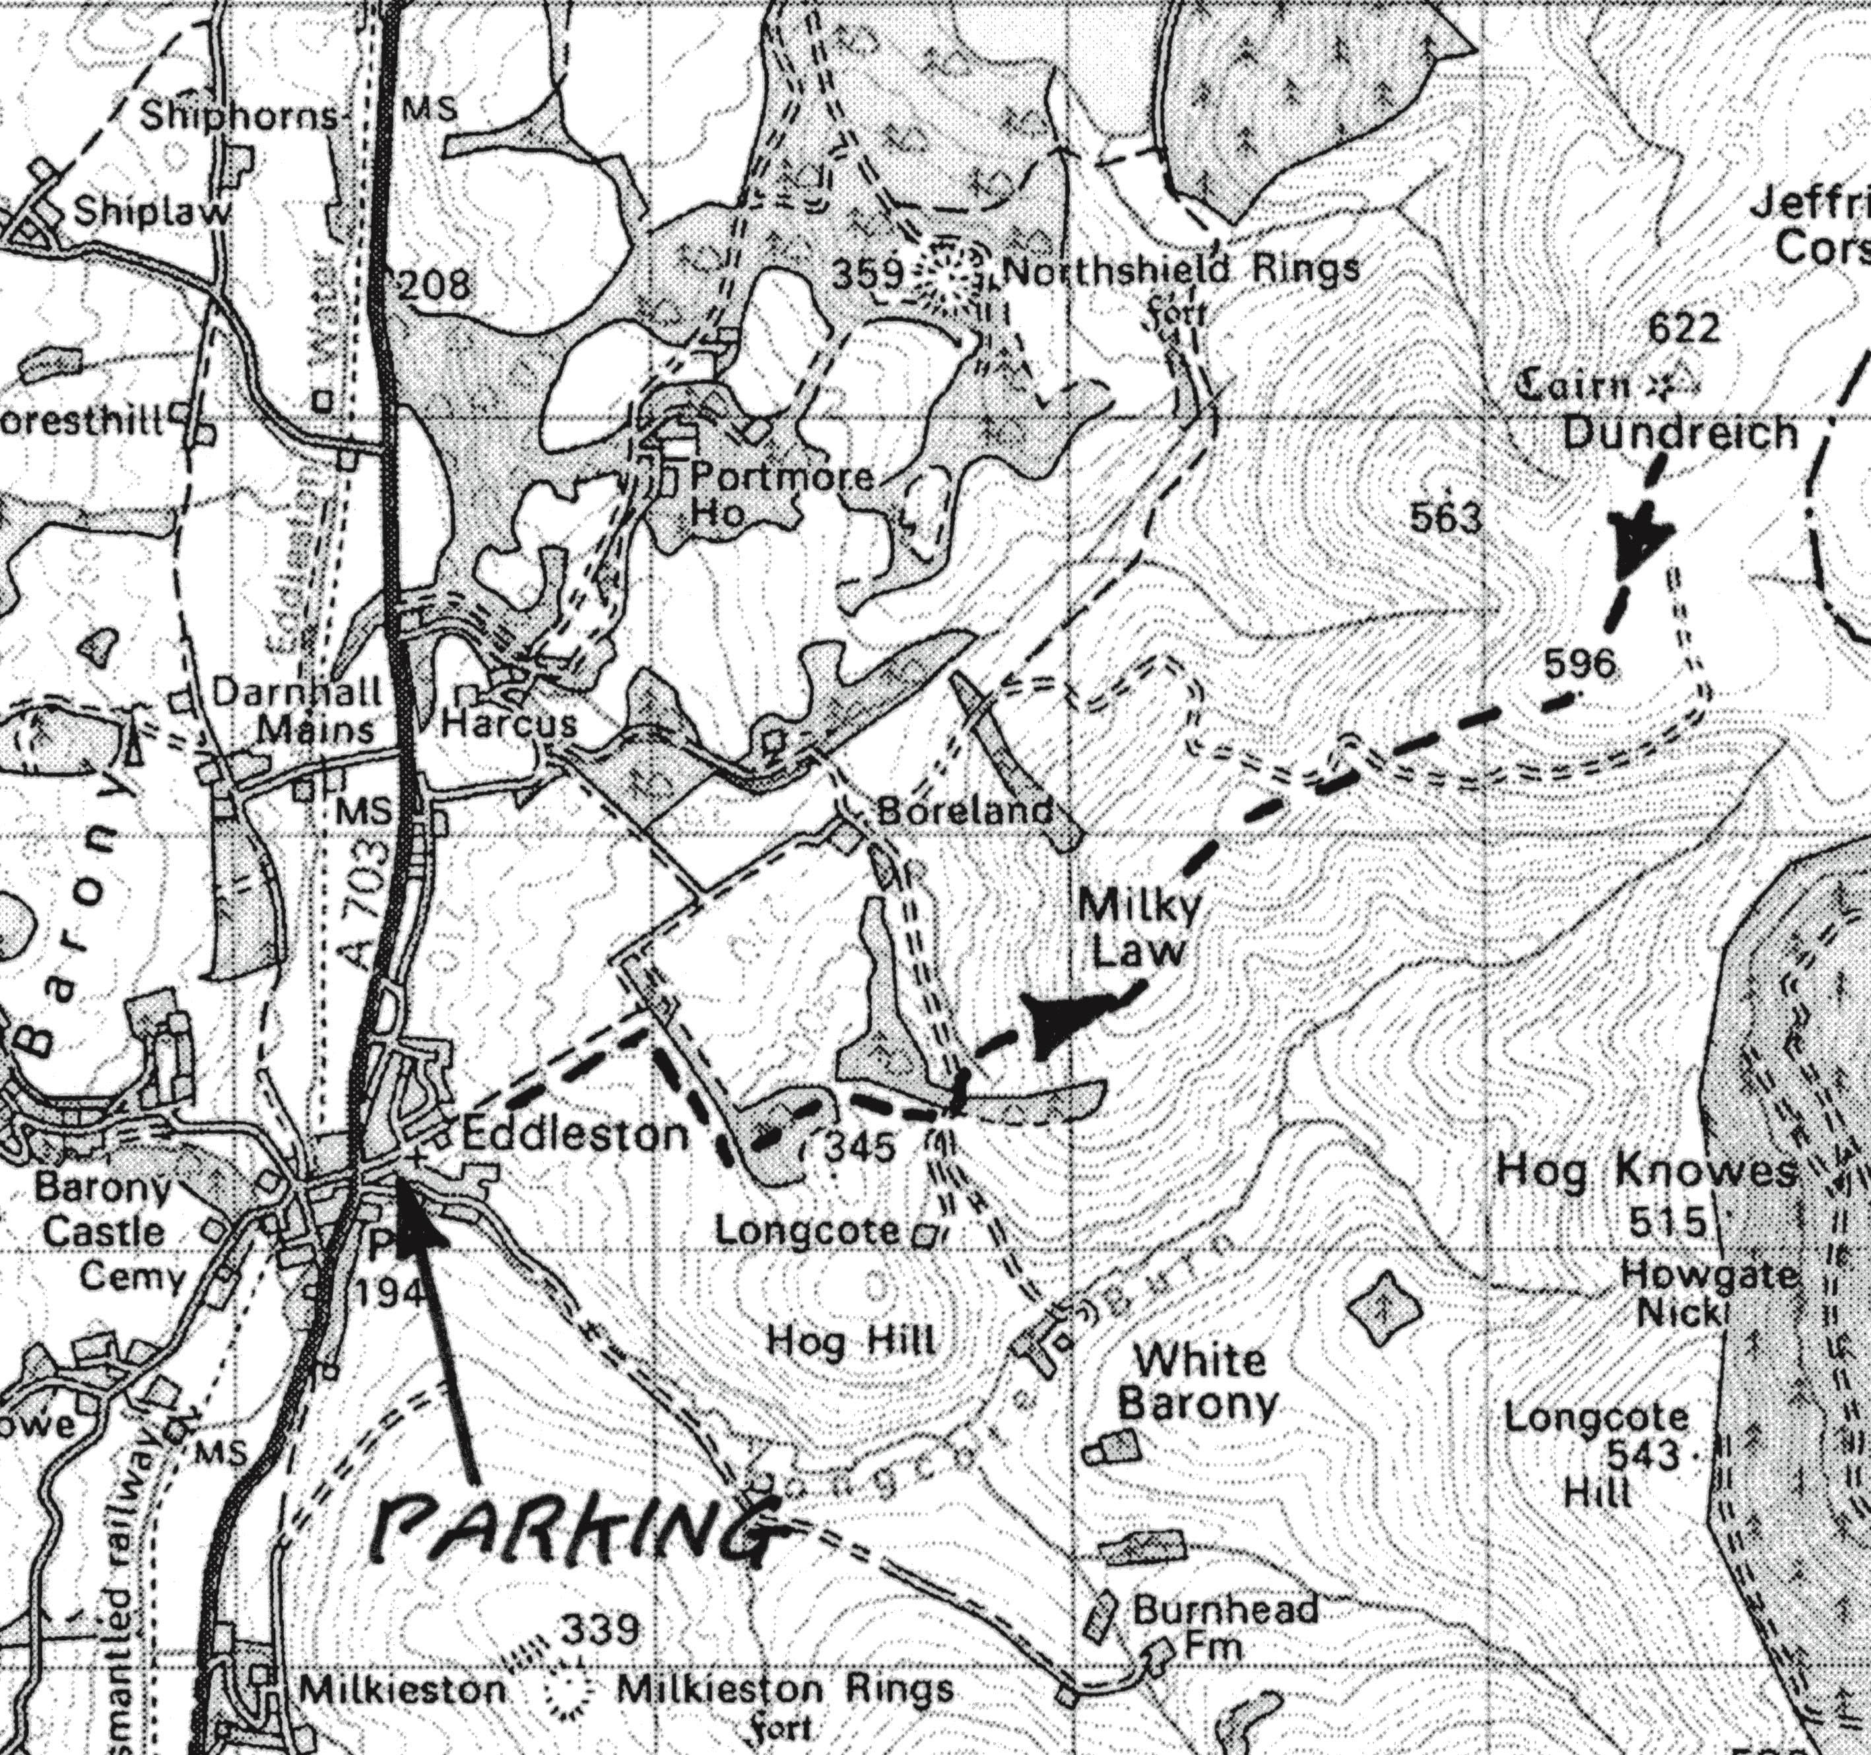
Follow footpath up hill past the kirk, then road between houses, continuing into a grassy lane leading to metal gate. Continue up along left of wall until a strip of trees; through this and turn right, then work through several small woods to reach the track leading south from Boreland farm. From here head up to Milky Law, then spot height 596, then to Dundreich at 622m. Return same way, or via the track past Boreland farm buildings.

