Jacobites Mountaineering Club – Evening Walks

Dundreich from Portmore Loch – Moorfoot Hills, An 8km round trip up steeply onto a plateau with return along shore of a fishing loch. Park beside road just before the private road leading to Portmore Loch as approaching Westloch farm at NT 256 515. About 50 mins from Edinburgh.
Follow gravel road then branch up onto hill between the two blocks of forest (faint quadbike track). Continue up broad ridge to summit. Descend by track, or by ridge over spot height 563, back to lochside.

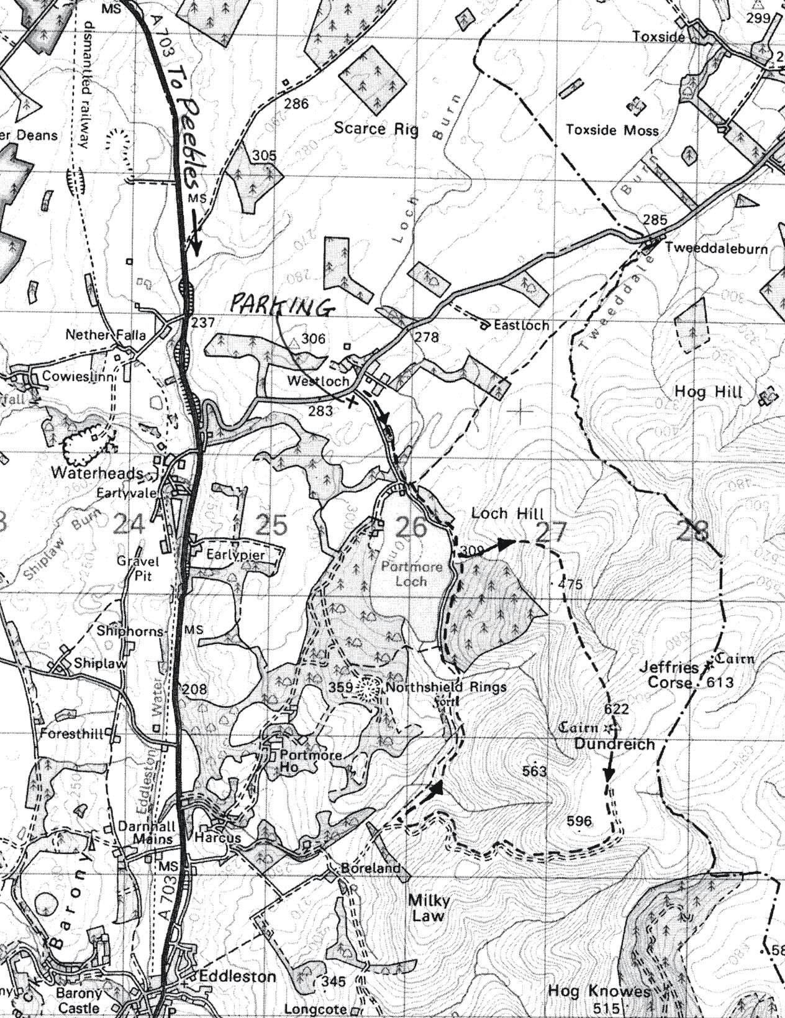

Contact:

