Jacobites Mountaineering Club – Evening Walks

Green Law, Broughton Heights, by Broughton. A medium walk starting up steeply onto a ridge and returning same way to gravel road for return, 7km round trip. Map 72, park at NT120375. 45 mins from Edinburgh. (Same start as for Trahenna Hill)
Follow the A701 road (for Moffat) and just before entering Broughton village turn left up narrow tarmac road, vaguely signposted (Broughton Place?). Follow this, passing the big house, to carpark by cottage. Follow track and before small wood on left go down to Hollows Burn and up onto Clover Law. Down and up to Broomy Side, Green Law and to cairn on Broughton Heights. Return same way until the track between Broomy Side and Clover Law and follow the gravel track back.

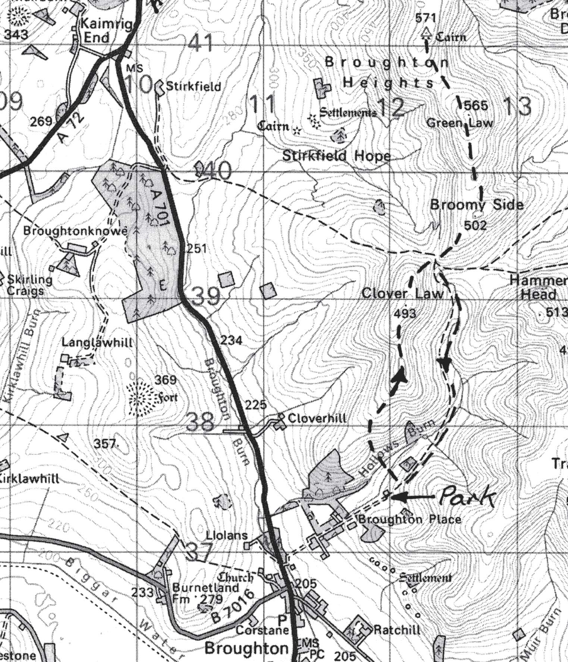

Contact:

