Jacobites Mountaineering Club - Evening Walks
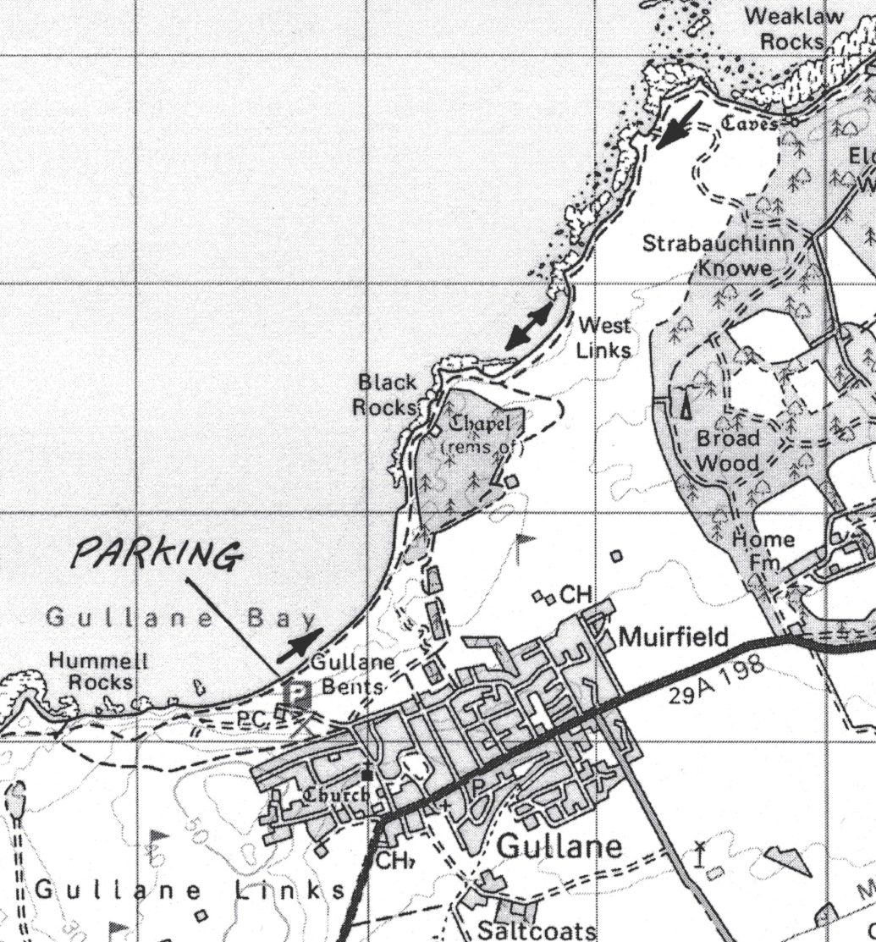
Gullane Bents to Weaklaw Rocks. A nice flat walk, with scope for cragging, skinny dipping and bird-watching. Follow A198 road toward North Berwick, but at Gullane look out for sign to beach parking at second left turn once in Gullane village, Map 66, NT476832. Head north east along the beach and pick up the path as marked on map to get up onto the grassy headlands around the rocks if the tide is high. Weaklaw Rocks or further if the urge takes us. Return by same route.

